Analysis Report

Executive

Introduction: This report provides results obtained through random forest regressor machine learning model. This study is done on bank marketing campaign data regarding the placing of positive term deposits. This report will pay particular attention to method algorithm used and will highlight its outcome of prediction, evaluate it based on the observed datasets. The report will comment on the prospects of the company and make recommendations that would improve positive deposits and correct way of customer contacting. These observations do have limitations which will be noted. This report will explain how a positive deposit could be enhanced.

Background:
Problem definition
The task at hand was to analyses a given set of data provided, perform a prediction of it using machine learning algorithms and end with a predictive model that can be adopted and applied on an existing dataset to predict outcome. The dataset describes Portugal bank marketing campaigns results. Conducted campaigns were based mostly on direct phone calls, offering bank client to place a term deposit.
If after all marking efforts client had agreed to place deposit - target variable marked 'yes', otherwise 'no'.
This data was provided for in the link below:
https://www.kaggle.com/volodymyrgavrysh/bank-marketing-campaigns-dataset
.

Purposes: The purpose is to determine an effective method of determining of analyzing bank data to predict the most effective means to contact current bank clients and engage them positively and influence of convince them to have a positive term deposit. The task will entail the use of random forest regressor. The random forest algorithm will be used using the Scikit-Learn Python library.

Limitations: Some data with unknow values were limited I the cleaning process which could have some influence on the model.

Project questions
- What is the age distribution in this data set?
- How many people were contacted by phone and have positive term deposit?
- Did the term deposit increase or decrease in the past?
- What is the likelihood trend with the current market structure?
- What factors dictates the likelihood of a positive term deposit?

Methods: Data from the bank was provided in a csv file format.
Then important libraries were imported in Juypter notebook. The dataset was downloaded into the "Datasets" folder of the "C" Drive which was accessed using relative file path.
There some inconsistencies with some fields which required cleaning and removal of unknown values were:

- marital
- education
- default
- Housing
- loan

The following fields appear to have consistent data with no missing values or unknowns:

- contact
- month
- day_ of_the_week
- campaign
- pdays
- previous
- poutcome
- poutcome
- mp_ccons_price_idx
- cons_conf_idx_rate
- euribor3m
- nr_employed

This data was prepared for training and split to training and test sets. The data had to be scaled because pdays was in hundreds, nr_employed is in thousands and others in text. Scikit-Learn's StandardScaler class was used to execute that
After scaling random forest algorithm was used to solve this regression problem.
For regression problems the metrics used to evaluate an algorithm are mean absolute error, mean squared error, and root mean squared error.

Results:
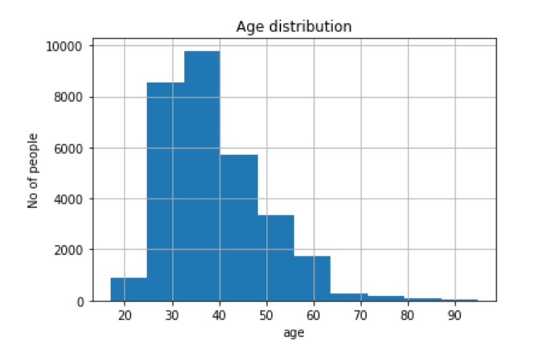
Figure 1: Population histogram:
The population is skewed to the right because most of those who own bank accounts are above school age and they peak at working ages
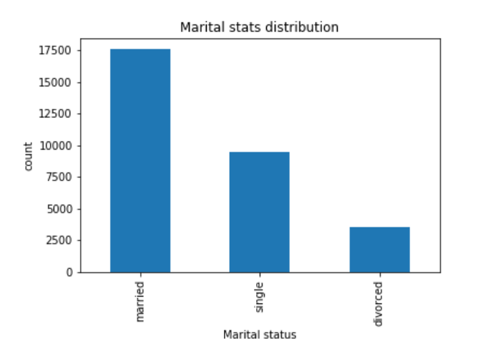

Figure 2: Marital status
A large number of the banks clients are married

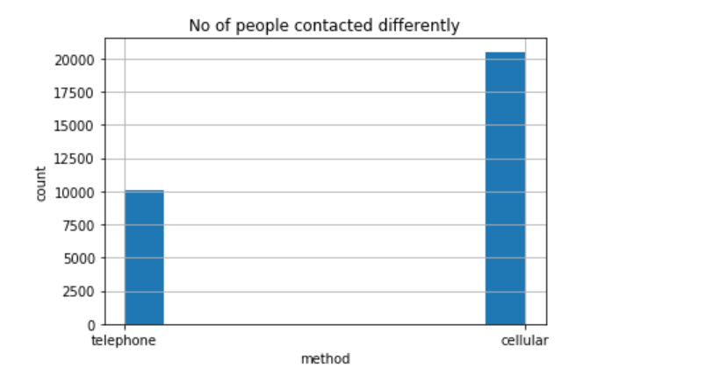
Figure 3: Contact methods
More people were contacted using cellphones

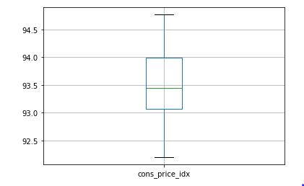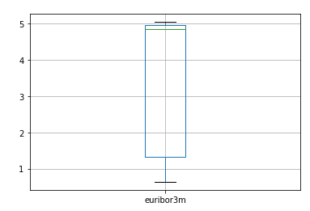
Figure 4: Box plots
The consumer price index had a wider standard deviation as compared to euribor3m
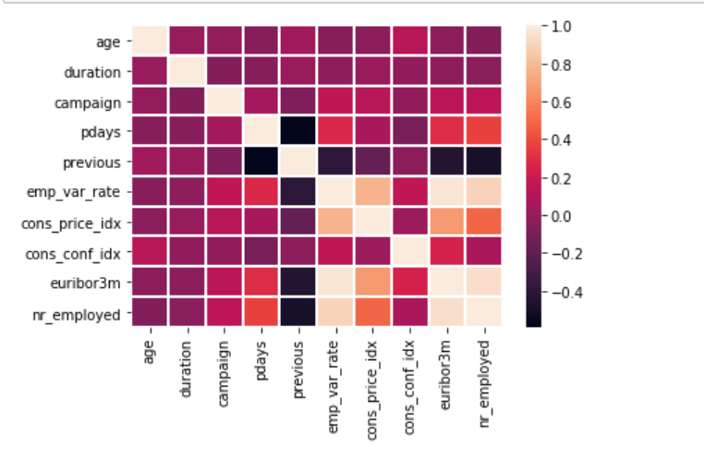
Figure 5: Correlation matrix
The dark cells represent -ve correlation while the bright light colors represent a strong +ve relations

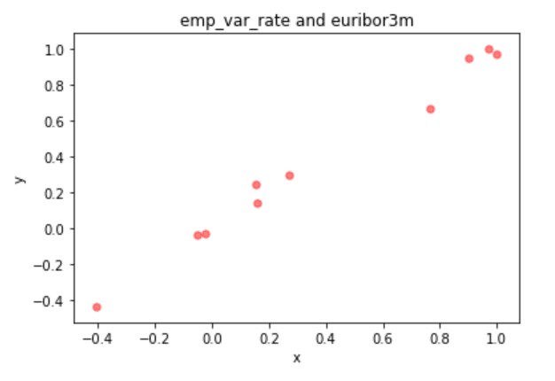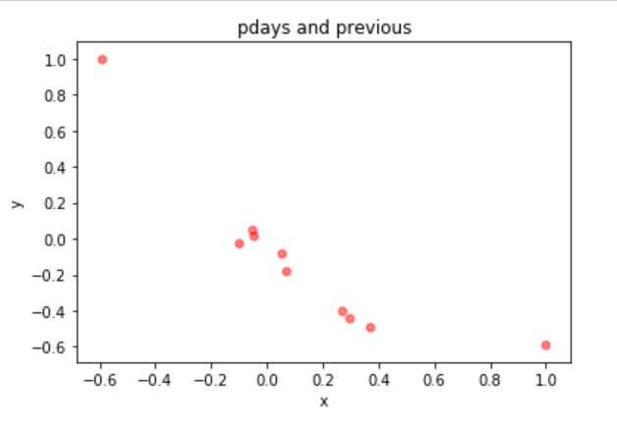
Figure 6: Scatter plots

From the correlation matrix, we can see that there is a high positive correlation between 'pdays' and 'previous'
From the correlation matrix, we can see that there is a relatively high correlation between 'emp_var_rate' and 'euribor3m'

Recommendations:

Mean of y is 0.12665 which is less than 10% of the root mean squared error is 0.0655.
This is a good regressor tool.

Project answers
- What is the age distribution in this data set?
  - A high number of the clients are at age between 35 and 40
- What was the most common contact method used?
  - Use of cellphone
- Did the term deposit increase or decrease in the past?
  - The highest was in May and the lowest in December. It kept on fluctuating, with more twist I could have rearranged the plot to show a better time series
- What is the likelihood trend with the current market structure?
  - The regressor can be used to predict if a set is supplied
- Was the tool a success in modelling the data set
  - yes

Summary: This section presents a brief “easy to digest” synopsis of the report.

The random forest employed in this task was preferred because it proved to be:
- Unbiased, since, there are multiple trees and each tree is trained on a subset of data. The algorithm relies on the power of "the crowd"; therefore, the overall biasedness of the algorithm is reduced.
- Is very stable. Even if a new data point is introduced in the dataset the overall algorithm is not affected much since new data may impact one tree, but not all the trees.
- robust when there is both categorical and numerical features.
- Effective even with data has missing values or it has not been scaled well (although feature scaling was performed in this ask).

References:
Aigraz training materials

